Computational Dictionary

What is Computational Dictionary
# Source: AI Source: Provided by: [Data Path: Persons Table -> ID Column: 1, Name_En Column: Motasem Essam] -> From: [Chatgpt (GPT-4-turbo)] on [7/29/2025]
A Computational Dictionary is a machine-readable lexicon designed to be used by computer programs, especially in fields like Natural Language Processing (NLP), Artificial Intelligence (AI), machine translation, and linguistic modeling. Unlike traditional dictionaries, it stores linguistic information in structured, searchable formats, often including syntactic, semantic, and morphological data.

🔹 Key Features of a Computational Dictionary
# Source: AI Source: Provided by: [Data Path: Persons Table -> ID Column: 1, Name_En Column: Motasem Essam] -> From: [Chatgpt (GPT-4-turbo)] on [7/29/2025]
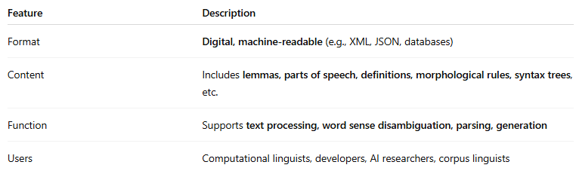
Feature | Description
Format | Digital, machine-readable (e.g., XML, JSON, databases)
Content | Includes lemmas, parts of speech, definitions, morphological rules, syntax trees, etc.
Function | Supports text processing, word sense disambiguation, parsing, generation
Users | Computational linguists, developers, AI researchers, corpus linguists

🔹 Examples of Computational Dictionaries
# Source: AI Source: Provided by: [Data Path: Persons Table -> ID Column: 1, Name_En Column: Motasem Essam] -> From: [Chatgpt (GPT-4-turbo)] on [7/29/2025]
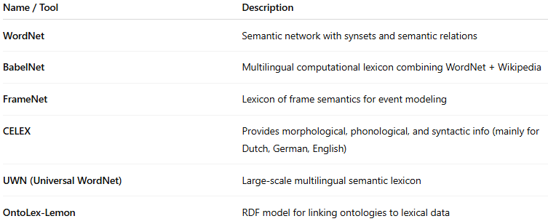
Name / Tool | Description
WordNet | Semantic network with synsets and semantic relations
BabelNet | Multilingual computational lexicon combining WordNet + Wikipedia
FrameNet | Lexicon of frame semantics for event modeling
CELEX | Provides morphological, phonological, and syntactic info (mainly for Dutch, German, English)
UWN (Universal WordNet) | Large-scale multilingual semantic lexicon
OntoLex-Lemon | RDF model for linking ontologies to lexical data

🔹 Advantages
# Source: AI Source: Provided by: [Data Path: Persons Table -> ID Column: 1, Name_En Column: Motasem Essam] -> From: [Chatgpt (GPT-4-turbo)] on [7/29/2025]
- Enables semantic search, language modeling, and text understanding
- Powers machine translation, chatbots, and text analysis tools
- Facilitates multilingual NLP through cross-linguistic linking
- Offers customizability for domain-specific or task-specific applications

🔹 Use Cases
# Source: AI Source: Provided by: [Data Path: Persons Table -> ID Column: 1, Name_En Column: Motasem Essam] -> From: [Chatgpt (GPT-4-turbo)] on [7/29/2025]
- Natural Language Understanding (NLU)
- Chatbots and virtual assistants
- Corpus annotation and analysis
- Machine translation and localization
- Speech recognition and synthesis

